Pilot’s Guide
ORS 01 and 02
KLN 94
Bendix/King®
GPS Navigation System

Abbreviated Operation Summary

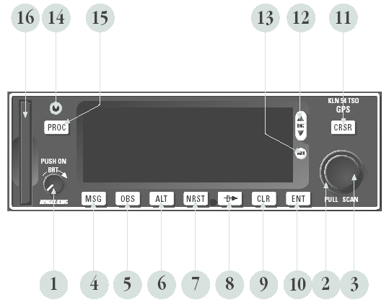

1. On/Off/Brightness knob – Used to turn the unit on and off and adjust display brightness.
2. Right outer knob – When the cursor is off, used to select the page type (e.g. APT, NAV, FPL, etc.). When the cursor is on, used to move the cursor from one position to another on the display.
3. Right inner knob – When the cursor is off, used to select the specific page number for a page type (e.g. APT 1, APT 2, APT 3, etc.). When the cursor is on, used to select alphanumeric or other applicable data for the field the cursor is on.
4. Message button – Used to view messages.
5. OBS button – Used to select between LEG mode and OBS modes
6. Altitude button – Used to select the two Altitude pages where baro settings are made and VNAV operation is set up.
7. Nearest button – Used to bring up a menu of nearest functions (Airports, VORs, NDBs, Intersections, etc.) that may be selected.
8. Direct To button – Used to initiate Direct To operation.
9. Clear button – Used to delete data from a data field. Also used to back up to a previous step in some instances such as selecting approaches/STARs/DPs
10. Enter button – Used to approve or acknowledge data.
11. Cursor button – Used to turn the cursor on and off.
12. Range button – Used to change the map scale if the map page (Nav 4) page is being displayed. Used to select the map page if it is not already on the map page.
13. Menu button – Used to display the map menu if the map page (Nav 4) page is being displayed. The map menu is used to initiate changing what is displayed on the map as well as select the map orientation. Used to select the map page if it is not already on the mappage.
14. Data loader jack – Used when updating the Aeronautical database from a computer.
15. Procedure button – Used to initiate the loading of approaches, arrival procedures, and departure procedures. Also used to activate vector–to–final (VTF) for approaches when an approach with “Vectors” has been loaded into the active flight plan.
16. Data card – Contains the KLN 94 database.
Operation

To turn on and initialize the KLN 94:
1. Turn on the KLN 94 by pushing in the On/Off/Brightness knob. For the first few seconds a single color Power-On page is displayed at a fixed brightness. Press the "Enter" button following each "test page".

2. Use the right inner knob to enter the current altimeter setting into the “Baro” field and then press the "ENTER" button.

3. If the KLN 94 has passed the internal self-test, the bottom of the Self Test page will display Pass and all external annunciators (if any installed) should be illuminated. If instead, Fail is displayed, recycle power to the KLN 94. If the Self Test page still displays Fail, the KLN 94 requires repair and should not be used for navigation.
4. To navigate "Direct" to an airport, press, then enter the airport identifier using the "K" before it (example: KCAE)

Use the outer knob to select cursor position, use the inner knob to select the numerical or letter of the alphabet. Press "Enter" after selection is entered, then verify entry and press "Enter" the second time to retain selection.
To clear the entry, press and enter next waypoint using the steps above.

5. To view moving map, press "Range" to view. Map will not display until the aircraft is in motion. You can increase or decrease the range by toggling the "Range" button.
6. To locate nearest airport press. .

7. Message indicator is in a yellow box. Messages are viewed by pressing. To clear message press "Message" button again.
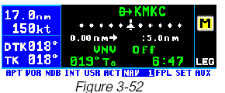

To create a user-defined waypoint with latitude/longitude:
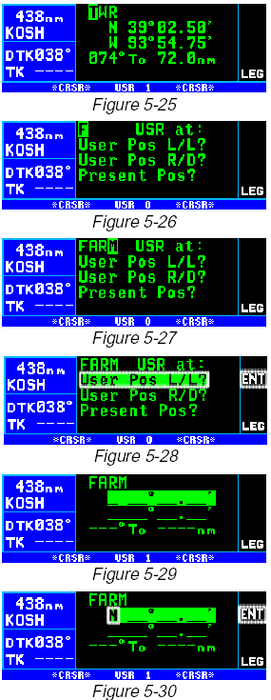
1. From any user waypoint (USR) page, turn on the "cursor" button.
It will be over the first character in the waypoint identifier field
(figure 5-25).

2. Use the right inner knob to select the first character of the
identifier (figure 5-26). Remember that when the cursor
is on, the right inner knob changes the character and the
right outer knob moves the cursor around.

3. Spell out the rest of the identifier using the right inner and outer
knobs (figure 5-27).

4. Move the cursor down to the second line, over User Pos L/L?
(figure 5-28).

5. Press "Enter". The display will change to a format like figure 5-29.

6. Use the right inner knob to select N for north or S for south
(figure 5-30).

7. Use the right outer knob to move the cursor, and the right inner
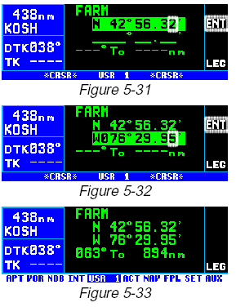
knob to select the proper numbers to complete the latitude
entry (figure 5-31).

8. Press "Enter". The cursor will move to the longitude field.

9. Enter the longitude in the same manner as the latitude (figure 5-32).

10. Press "Enter" to approve this position. The cursor will automatically
turn off (figure 5-33).

